

STP
Synchronous Transport Protocol

Document Owner:

Dave Rathnow, Software Architect

Document Version:

0.1

Table of Contents
Introduction 4
Overview 4
FAD – Fragment Assembly/Disassembly 5
FAD Timers and Counter 5
Packet Format 6
CRC Calculation 7
Message Handling Algorithm 8
Resend Request 10
APL – Application Packetization 13
Escaping Payload Data 13
GDN Messages and Responses 15
Controls and Responses 15
Field Data Types 16
GDN Packet Format 16
GDN Messages 17
Report Message 18
Configure Alarm Message 21
Set Events Message 22
Set Events Response Message 24
Add Extended IO Point 26
Delete IO Point Message 27
Demand Poll Message 27
Write IO Point Message 27
Request Time Message 27
IO Refresh 29
IO Refresh Message 29
IO Refresh Response Message 31
Set Events Message 31
IO Refresh example 31
PAC Console Messages 32
PAC Console Close Command 32
PAC Console Command Message 32
PAC Console Display Message 32

Introduction
The Synchronous Transport Protocol (STP) was first developed in 2001 to facilitate guaranteed delivery of data between a remote ZedPACs and the PAC Bridge. It was designed to send small packets of data over communication networks that had limited reliability and bandwidth. The purpose of the protocol was to take a message and fragment it into smaller messages, called segments, send them to a remote destination, where they would be reassemble, and then have an acknowledgement sent back to the source indicating successful delivery of the data.
GDN Message is what we refer to as the message format use to send commands and data between the ZedPAC and the PAC Bridge. GDN messages can loosely be categorized into two types of message: Controls are sent to the ZedPAC by the PAC Bridge; and Requests are sent by the ZedPAC to the PAC Bridge.
This document describes the STP protocol and GDN Message formats. It is assumed that the reader has a basic knowledge of how the ZedPAC operates and understands what an IO Point is and how it is mapped in the ZedPAC. Unless otherwise stated, all byte-ordering in this document is Little Endian, meaning the first byte (lowest address) is the least significant byte and the last byte (highest address) is the most significant byte.
This document describes the STP protocol and GDN Messages as they relate to ZedPAC firmware version 6.0 and higher. The STP protocol and GDN Messages used by firmware version other than these are beyond the scope of this document and are not discussed.

Overview
STP is an application level transport protocol, meaning it has no knowledge of the underlying communication medium used to transport data to and from a remote destitution. The primary purpose of STP is to facilitate guaranteed message delivery between two end-points. It does this by using a command response model where each sent message must be acknowledged by the receiver. If the receiver does not acknowledge in a timely manner, the message will be resent up to a max number of times before the message is discarded. The application is then notified of this failure and it can decide what action to take.
STP has two primary layers: an upper layer that manages the segmentation of messages (FAD – Fragment Assembly/Disassembly) and a lower layer that manages the framing of messages (APL – Application Packetization Layer).
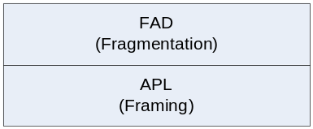
Figure 1 - STP Layers
Note: through this document the terms “FAD acknowledgement” and “STP acknowledgement” are used interchangeably. The reader can assume that “STP acknowledgement” is equivalent to the “FAD acknowledgement”.

FAD – Fragment Assembly/Disassembly
The FAD protocol allows messages to be broken up into multiple segments with each segment being sent independently of others. Each segment is assigned an ID so that when segments arrive at their destination, they are ordered and the original message reassembled after the last segment has arrived. FAD also provides the ability to request that a missing segment be resent, should that segment be missing when the last segment has been received.

FAD Timers and Counter
In order to track the progress of messages and segments, FAD maintains a number of timers and counters that determine when and if a message should be resent or discarded. All timers are measured in seconds.

Transmit Timeout – Outgoing Messages
The Transmit Timeout determines how long FAD will wait for an acknowledgement to a message before the message is resent. This value should be set according to the latency of the underlying communication medium used to send messages and segments.

Receive Timeout – Incoming Messages
The Receive Timeout determines how long FAD will wait for all message segments to arrive before the message is discarded. This applies to a destination FAD in a situation where a message has been broken into multiple segments but one or more of the segments does not arrive. This value should be set according to the latency of the underlying communication medium used to receive messages and segments.

Retry Count
The Retry Count determines the maximum number of times a message will be resent before it is discarded. Implementers should provide a facility for the application to be notified of this event so that it can take appropriate action.

Message Window
FAD has the ability to overlap the sending of messages to increase performance. This means it will allow more than one message to be “in-transit” without waiting for an acknowledgement. The number of in-transit message is referred to as the Message Window. The message window is currently limited to 4.

Packet Format
FAD packets consist of a header and a data portion. The header contains information used by FAD to determine the type of packet and action to take when handling the packet.
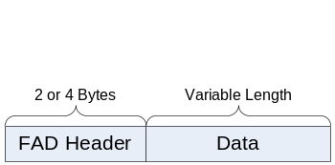
Figure 2 - FAD Packet Format

The header is divided into two sections: controls fields that determine how the packet is handled; and a two byte CRC value that is required for all but one type of packet. Figure 3 - FAD Header Format shows the format of a FAD header:

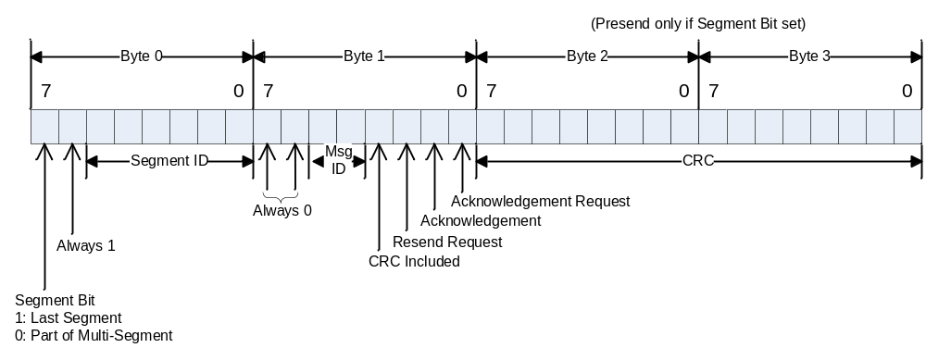
Figure 3 - FAD Header Format

Byte/Bit number | Field Name | Description
Byte – 0 Bit 7 | Last Segment Bit | Used to indicate a segment is the last segment in a message.
Byte 0 – Bit 6 | Extension Bit | Must always be set
Byte 0 – Bits 0 – 5 | Segment ID | Identifies the segment number of a multi segment message.
Byte 1 – Bit 7 | Ignored | Must be 0
Byte 1 – Bit 6 | Extension bit | Must be 0
Byte 1 – Bits 4 – 5 | Message ID | Message number. This value will be the same for all segments in a multi segment message.
Byte 1 – Bit 3 | CRC Bit | Indicates the presents of a CRC in bytes 2 and 3. This bit indicates the total size of the header  0: CRC is not present (2 byte header)  1: CRC is present (4 byte header)
Byte1 – Bit 2 | Resend Request | This is a resend request for a segment or entire message.
Byte 1 – Bit 1 | Acknowledgement | Indicates if this segment is an acknowledgement message.  0: Is not an acknowledgment  1: Is a acknowledgement
Bytes 2 and 3 | CRC Value | Optional 16 bit CRC Value.
Table 1 - FAD Header Field Definitions

CRC Calculation
This is a CRC-16-IBM calculation using the polynomial function: x¹⁶ + x¹⁵ + x² + 1.

The following example shows how a byte sequence would be wrapped in a FAD header.
Byte Sequence: 48 65 6C 6C 6F 20 57 6F 72 6C 64
Checksum value: DA ED (decimal 56045)
The resulting packet would be:
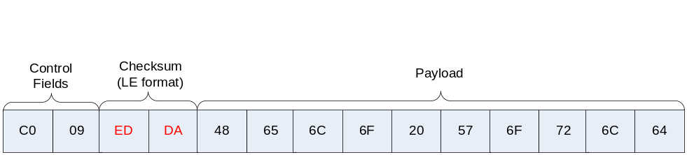
Figure 4 - FAD Packet Example

Message Handling Algorithm
Each message sent by FAD is assigned a message ID in the range of 0 to 15. Because the number of messages IDs is limited, FAD restricts the number of messages that can be outstanding (i.e. sent but not yet acknowledged). Once a message has been acknowledged, the message ID is reused.
Messages are fragmented into segments with each segment being assigned a segment ID in the range of 0 to 63. The size of a segment is determined by the source FAD so it’s important that the source FAD uses a segment size that is reasonable for the destination FAD. For most application a segment size of 1024 bytes should be sufficient. For messages that will fit into a single segment, the following fields must be set:
Field | Value
Last Segment | 1 | Must be set
Segment ID | ID | ID of the segment
Message ID | ID | ID of the message
CRC Included | 1 | CRC included
Resend Request | 0 | Must be clear
Acknowledgement | 0 | Must be clear
Acknowledgement Request | 1 | Must be set
CRC | CRC16 | CRC calculated from the payload of the entire message. This must be provided.
Table 2 - Single Segment Message Header Fields
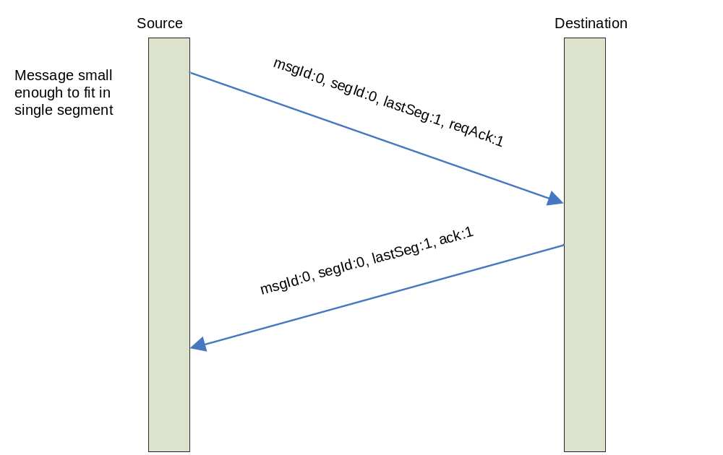
Figure 5 - Single Segment Message Sequence

If a message is too large to fit into a single segment, it will be separated into smaller segments and each segment sent as a separate packet, however, individual FAD Segments are not acknowledging. Only complete messages are acknowledged. The acknowledgement bit will be ignored for all segment packets except the last segment of a multi segment message. The following fields must be set for a multi segment message header for all segments except the last one:
Field | Value
Last Segment | 0 | Must be clear
Segment ID | ID | ID of the segment
Message ID | ID | ID of the message
CRC Included | 0 | Must be clear
Resend Request | 0 | Must be clear
Acknowledgement | 0 | Must be clear
Acknowledgement Request | 0 | Must be clear
CRC | N/A | CRC is not included.
Table 3 - Multi Segment Message Header Fields For All But Last Segment
The last segment header must have the following header fields set:
Field | Value
Last Segment | 1 | Must be set
Segment ID | ID | ID of the segment
Message ID | ID | ID of the message
CRC Included | 1 | Must be set
Resend Request | 0 | Must be clear
Acknowledgement | 0 | Must be clear
Acknowledgement Request | 1 | Request acknowledgement of the message
CRC | CRC16 | CRC must be included.
Table 4 - Multi Segment Message Header Fields for Last Segment
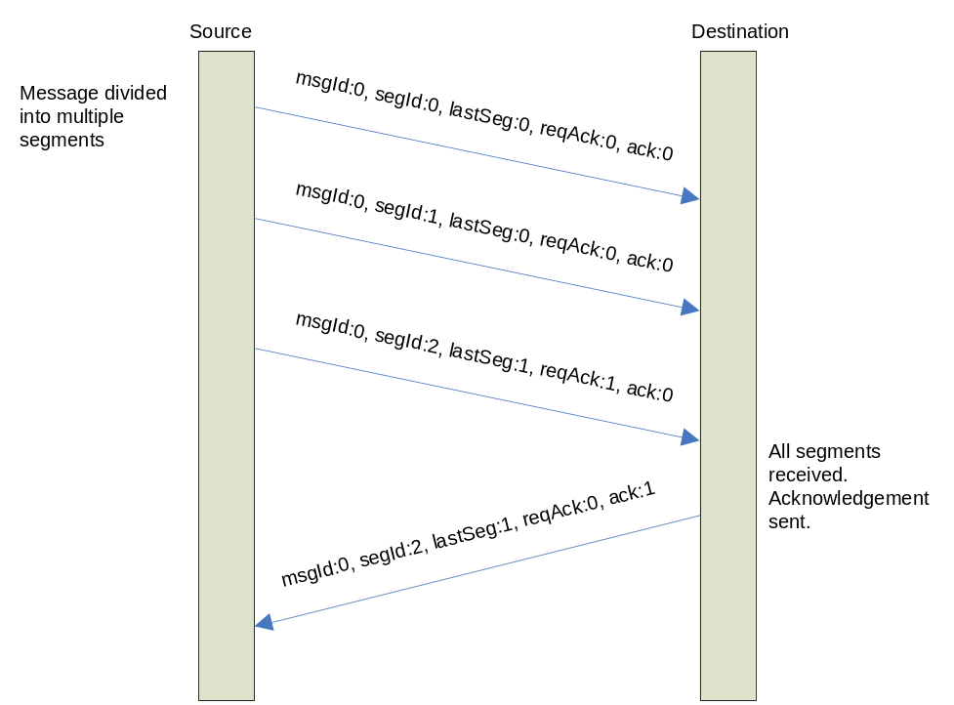
Figure 6 - Multi Segment Message Sequence

Resend Request
When all the segments of a message have arrived, the destination FAD will verify that all message segments are present. If a segment is missing, a RESEND request can be sent to request that an individual segment be resent or the entire message. This is done by setting the “Resend Request” bit and then either clearing the last segment bit for an individual segment or setting it for the entire message. If the last segment bit is cleared, indicating a segment resend request, then the requested segment number is put in the “Segment ID” field. In either case, the “Message ID” filed must be set to the message ID of the requested message.

Field | Value
Last Segment | 0 | Indicates that the resend is for a single segment
Segment ID | ID | ID of the requested segment
Message ID | ID | ID of the message
CRC Included | 1 | Must be set
Resend Request | 1 | Request to resend segment
Acknowledgement | 0 | Ignored
Acknowledgement Request | 0 | Ignored
CRC | CRC16 | CRC must be included. The CRC is calculated from the first two bytes of the header.

Table 5 – Resend Segment Request Header Fields
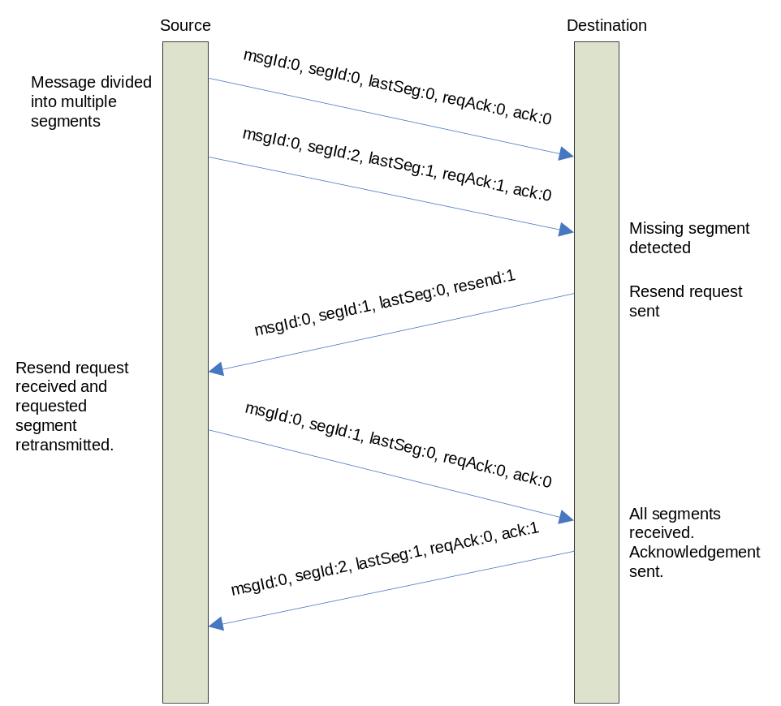
Figure 7 - Resend Segment Sequence
Resending of an entire message may be requested and is typically only done when the CRC value is bad. If a resend of the entire message is requested, the header must have the following fields:
Field | Value
Last Segment | 1 | Indicates that the resend is for an entire message.
Segment ID | ID | Ignored
Message ID | ID | ID of the message
CRC Included | 1 | Must be set
Resend Request | 1 | Must be set
Acknowledgement | 0 | Ignored
Acknowledgement Request | 0 | Ignored
CRC | CRC16 | CRC must be included. The CRC is calculated from the first two bytes of the header.
Table 6 - Resend Message Header Fields
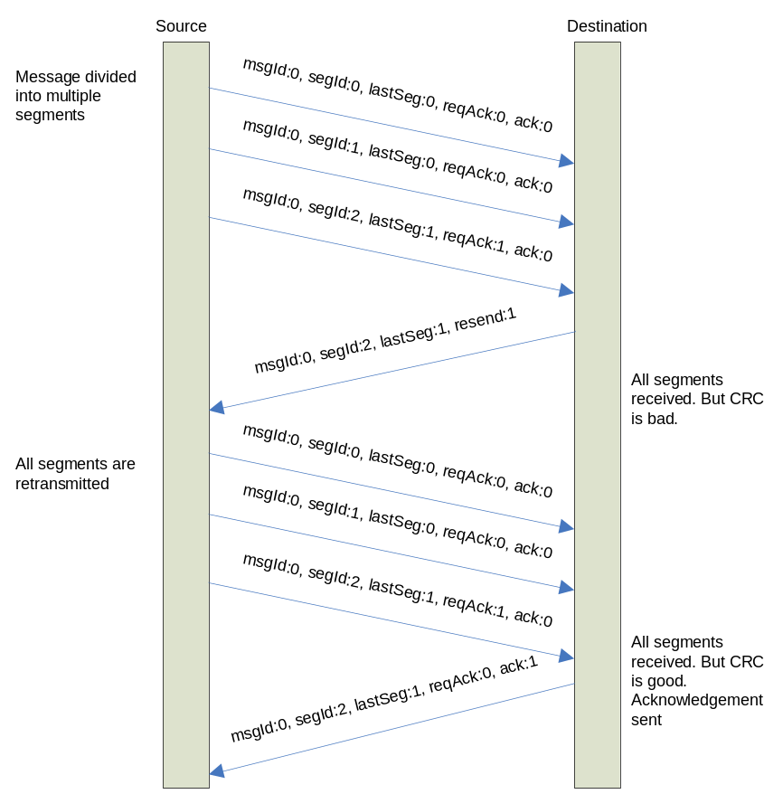
Figure 8 - Resend Message Sequence

APL – Application Packetization
APL is a simple framing protocol that allows multiple messages to be multiplexed over a single communication channel. The protocol marks the beginning and ending boundaries of a frame and provides a checksum byte to ensure accurate data delivery. Frame boundaries are indicated by an escape character (0x1B) followed by a control character, 0x02 for start-of-frame and 0x03 for end-of-frame. The third-to-last byte contains an 8 bit checksum calculated from the payload data.
The following shows a typical APL Frame

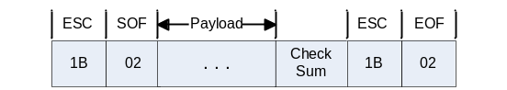
Figure 9 - APL Packet Format

Byte Sequence | Description
0x1B 0x02 | Start-of-Frame
Checksum | LRC Checksum of the payload calculated before escaping all characters.
0x1B 0x03 | End-of-Frame
Table 7 - APL Framing Characters

Escaping Payload Data
Before payload data is framed, a scan is made of the data (including the checksum) to detect any SOF, EOF or ESC bytes. These characters are replaced with escape sequences so they do not interfere with the marking of frame boundaries. Note that all checksum calculations are performed on the raw payload, that is, before escaping on the transmit end and after reverse escaping on the receiving end. The following table shows the replacement characters used:
Payload Byte | Replacement
0x02 | 0x1B 0x04
0x03 | 0x1B 0x05
0x1B | 0x1B 0x1B
Table 8 - APL Escape Codes
The following examples show how a sequence of bytes would be encoded by APL:
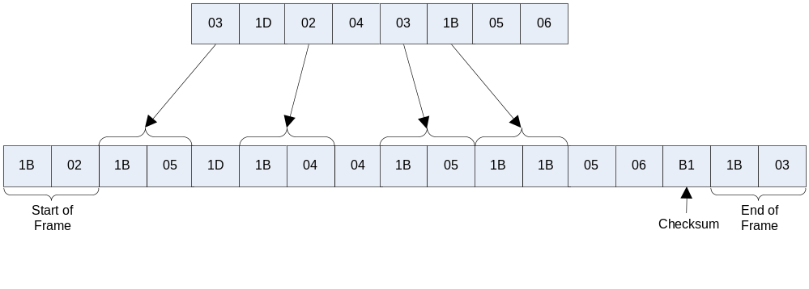
Figure 10 - APL Frame Example
When a packet arrives, the payload goes through a reverse escaping process to transform escaped sequence back to their original byte values. Once all the escaping is done, a check sum is performed on the resulting data and compared to the checksum value in the third to last byte of the frame. If the checksums match, the packet is accepted. If the checksums do not match, the packet is discarded and no further action is taken.

GDN Messages and Responses
GDN Messages are used to send and receive commands and data between the ZedPAC and the PAC Bridge. For all but the Report Message, a response is expected to verify that the message was accepted and processed. This response is not the same as the STP acknowledgement described in earlier sections of this document. The STP acknowledgement only verifies that the message was delivered. The response to a GDN message indicates that the message was accepted, processed, and the results of processing the message. The details of how the ZedPAC processes each type of message and generates the response are beyond the scope of this document
As mentioned, the Report Message is a special case message that is handled differently by the PAC Bridge. It is created and sent by ZedPAC to the PAC Bridge in response to various events that occur in the ZedPAC. The bridge does not send an explicit report response to the ZedPAC when it handles a report message. Instead, it will hold the STP acknowledgement until it has successfully parsed and persisted the data from the report. This guarantees that any report received by the bridge will not be lost.
The only other message initiated and sent by the ZedPAC is the Request Time message. In this case, the bridge will send a response to the ZedPAC that is different than the STP acknowledgement.

Controls and Responses
Any command sent by the PAC Bridge to the ZedPAC is referred to as a control. The purpose of the control could be to change the configuration of the ZedPAC or a command to have the ZedPAC execute a function. In all cases, the ZedPAC will always send a response message to indicate the results of the action. This response is different than the STP acknowledgement described in previous sections. The response comes in the form of a Report Message that contains the IO Point(s) that is (are) affected by the control. In the case of the Extended Report Message, the reason for the Report is included in the report header in the Reason Code field. However, it is important to point out that there is not always a one-to-one correspondence between the Reason Code field and the event that cause the report to be sent in. For example, a request to set the value of an IO point could cause the IO point to exceed an alarm threshold value. In this case, the report message send in response to the demand poll would include a Reason Code that indicated the report was generated as a result of an Alarm Trigger rather than a Demand Poll.
If the ZedPAC could not process the control, it will send back a Report Message with the pollset number set to 255 and a single IO Point index 255. The value of the IO Point will indicate the error condition. As of this writing, there is only one error code:
Error Code | Description
2 | Invalid index or pollset number
Table 9 - GDN Error Codes
The other GDN Message that should be discussed is the Request Time message. This message is sent by the ZedPAC to the PAC Bridge to synchronize its internal clock. The Request Time message is received by the bridge and a response sent back immediately. See the description of the Request Time message for a description of message format.

Field Data Types
Unless stated otherwise, the interpretation of data fields are done according to the following table:
Field Size | Description | Valid Range  Of Values
1 byte | Unsigned Byte | 0 to 255
2 bytes | Unsigned Short | 0 to 65535
4 bytes | Unsigned Long | 0 to 4294967295
Table 10 - GDN Message Field Data Types

GDN Packet Format
A GDN Packet is the packet format used to send and receive data between the PAC Bridge and the ZedPAC. A GDN packet consists of two parts: A switch header and message. The switch header contains information that indicates how to interpret the header and the associated message. The message portion contains a GDN Message.
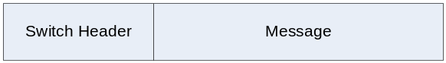
Figure 11 - GDN Packet Format
All Switch Headers contain a version number in the first byte of the header. There are currently two version of switch header in use.
Switch Header Version 10
Switch header version 10 is used when a session (see below) is not required by either the ZedPAC or the PAC Bridge. It is used most often used by the ZediPAC when it sends unsolicited messages to the ZedPAC Bridge. An unsolicited message is any kind of message that is the result of activity or an event on the ZedPAC that does not involve interactions with the PAC Bridge, such as an event to send in a scheduled report. The header contains two bytes:
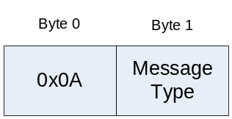
Figure 12 - Switch Header 10 Format
The first byte must be set to 0x0A (decimal 10). The message type (see Table 11 - GDN Message Types) identifies the message portion of the packet. When Switch Header Version 10 headers are used, the PAC Bridge responds with the same switch header version.
Switch Header Version 12
A Switch Header version 12 allows the creation of one or more sessions between the PAC Bridge and the ZedPAC. A session is required when multiple controls are multiplexed over a single channel to the ZedPAC. This allows the PAC Bridge to match responses from the ZedPAC with their associated controls. A Switch Header 12 contains a 16 bit field that contains a session ID to identify the session. The session ID is an unsigned short integer that is assigned by the bridge when the session is initiated. Session IDs start at 65535 and go down to 1 before they wrap around and start back at 65535. Once a session is initiated, all packets exchanged between the PAC Bridge and the ZedPAC must use a version 12 header and include that session ID.
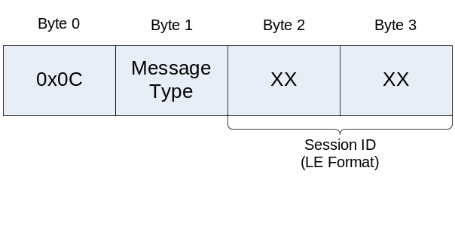
Figure 13 - Switch Header 12 Format
Setting up a session does not require any special hand-shaking between the ZedPAC and the PAC Bridge. To start a session, the PAC Bridge simply sends a GDN Packet with a Switch Header 12.

GDN Messages
Each GDN message is has a unique message number that is included in the Switch Header to indicate the type of message contained in a GDN Packet. The following table indicates the available message numbers:

Message Number | Name | Description
6 | Delete IO Point | Deletes an IO point from the ZedPAC
7 | Demand Poll | Demand polls a single IO Point of Pollset
8 | Write IO Point | Sets the value of an IO point
33 | Set Events | Used to add or delete an Event
38 | Report Message | Message used to report reading taken by the ZedPAC
40 | Request Time | Used by the ZedPAC to request a time from the PAC Bridge
42 | IO Refresh Command | Message used as part of the IO Refresh feature
43 | IO Refresh Response | Message used to respond to an IO Refresh Command message
45 | Configure Alarms | Configures alarm limits for an IO point
46 | Add IO Point | Adds an IO Point to the ZedPAC
47 | Set Events Response | Send by the ZedPAC in response to a Set Events Message
253 | PAC Console Close Command | Command to close a PAC Console session
254 | PAC Console Display | A message sent from the ZedPAC to the PAC Bridge that contains the output of a PAC console command.
255 | PAC Console Command | A command to the PAC Console
Table 11 - GDN Message Types

Report Message
An Extended Report Message is used by the ZedPAC to send IO point values to the PAC Bridge. The message contains fields that identify the pollset, time the IO point values were recorded, the reason for the report, and observed IO Point values.

Figure 14 - Report Message Format
Field Name | Description
Pollset Number | The pollset that the IO point(s) belong to
Timestamp | The timestamp the report was created. The value is a 4 byte, unsigned long that is the number of seconds since January 1, 1970 UTC.
Report Item Count | The number of report items contained in the Report Item section of the message.
Report Attributes | Attributes of the report (see below)
Report Items | Report Items that contain IO point values.
Figure 15 - Report Message Definitions
The Report Attributes contains additional information about the event that generated the report. The single byte is divided into two fields:
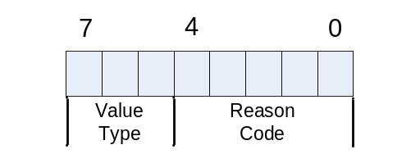
Figure 16 - Report Attributes
The value type field indicates what type of report items are contained in the report. Currently, the only value supported is 1. The Reason Code indicates the reason that the report was generated.
Value | Cause | Description
0 | Schedule Report | The report was generated as a result of a regularly scheduled reporting event.
1 | Demand Poll | The report was generated as a result of a demand poll.
2 | IO Modify | The report was generated as a result of an IO point being added to, or deleted from, the ZedPAC
3 | IO Write | The report was generated as a result of a value being written to an IO Point
4 | Alarm Modify | The report was generated as a result of an alarm being added, deleted, or modified
5 | Alarm Trigger | The report was generated as a result of an IO Point alarm being triggered.
Table 12 - Report Attribute Cause Codes

Report Item
A Report Item is a variable length structure that contains a reading from an IO point. The length of the item is determined by the data type of the value.

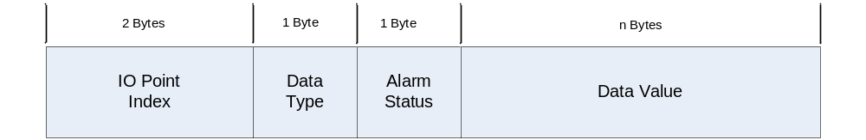
Figure 17 – Report Item

Field Name | Description
IO Point Index | The index number of the IO Point
Data Type | The type of the data value
Alarm Status | The alarm status of the IO Point
Data Value | The value of the IO Point.
Table 13 - Report Item Fields

Data Type  Name | Data Type Number | Size  (bytes) | Notes
Empty Value | 0 | 0 | No value provided
Discrete | 1 | 1 | 0 or 1
Byte | 2 | 1 | -128 to 127
Unsigned Byte | 3 | 1 | 0 to 255
Integer | 4 | 2 | -32768 to 32767
Unsigned Integer | 5 | 2 | 0 to 65535
Long | 6 | 4 | -2147483648 to 2147483647
Unsigned Long | 7 | 4 | 0 to 4294967295
Float | 8 | 4 | 1.4E-45 to 3.4028235E38
Blob | 11 | Variable | Blob values are specified by a variable length stream of bytes. The first two bytes of the data value specify the length of the blob. The length field does not include the two bytes for the length.
Table 14- Data Types

Alarm Status  Name | Type Number
OK | 0
Low | 1
Low Low | 2
High | 3
High High | 4
RTU Timeout | 5
RTU Error | 6
RTU Backoff | 7
RTU Overflow | 8
Table 15- Alarm Status

Configure Alarm Message
The Configure Alarm Message is used to configure or delete alarms on IO points. The message contains information about the IO point to apply the alarms to and a variable number of alarm values that enable or disable alarms.
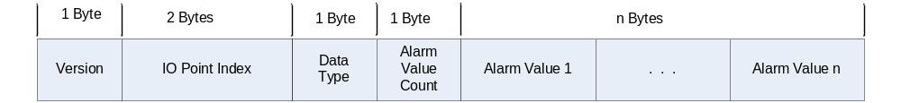
Figure 18 – Configure Alarm Message Format

Field Name | Description
Version | Must be zero
IO Point Index | Index number of IO point that the alarm is to be applied to.
Data Type | See Table 14- Data Types
Alarm Value Count | The number of extended alarm values
Table 16 – Configure Extended Alarm Message Field Definitions

Alarm Value
An Alarm Value is used to specify or delete an alarm setting for an IO Point.
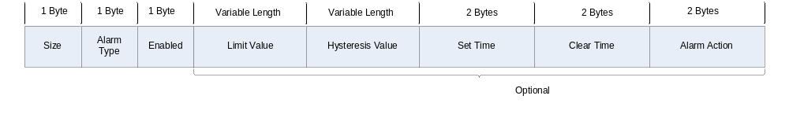
Figure 19 – Extended Alarm Value Format
Notice that the Limit Value, Hysteresis Value, Set Time, Clear Time, and Alarm Action fields are optional. They are not required when an alarm is disabled (deleted) or when the alarm type is Data Unavailable.

Field Name | Description
Size | Size, in bytes, of the Alarm Value
Alarm Type | The alarm type to be enables or disabled. See Table 18 - Alarm Types
Enable | Determines if the alarm is enable or disabled  1: Enable  0: Disable (deleted)
Limit Value | The limit value for the alarm
Hysteresis Value | The Hysteresis value
Set Time | The number of seconds an alarm must be recognized before it triggers.
Clear Time | The number of seconds an alarm must be within its acceptable range before it is cleared.
Alarm Action | Reserved for future use.
Table 17 - Extended Alarm Value Fields

Alarm Type Name | Value
Low | 1
Low Low | 2
High | 3
High High | 4
Data Unavailable | 6
Table 18 - Alarm Types

Set Events Message
The Set Events Message is used to configure or delete a scheduled event from the ZedPAC’s internal event database.
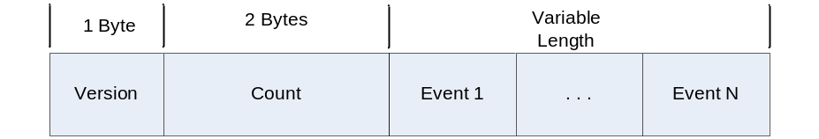
Figure 20 - Set Events Message Format
Field Name | Description
Version | Must be zero
Count | Number of events contained in the message
Table 19- Event Message Fields

Event
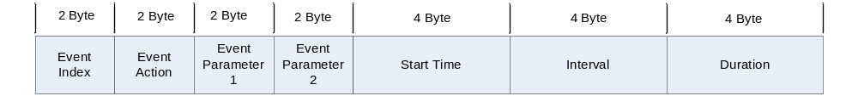
Figure 21 - Event Format

Field Name | Description
Event Index | The event index number
Event Action | Action to take when event triggers
Event Parameter 1 | Event Action specific parameter
Event Parameter 2 | Event Action specific parameter
Start Time | Start Time for the event
Interval | Interval between events
Duration | How long the event should last
Table 20 - Event Fields

Event Action | Number
Delete | 0
Poll | 1
Report | 2
Reboot | 4
Table 21 - Event Actions

Event Parameters
Event parameters are specific to an Event Action.
Event Action | Parameter 1 | Parameter 2
Delete | N/A | N/A
Poll | Pollset number | N/A
Report | Pollset number | Report Priority
Reboot | N/A | N/A
Table 22 - Event Paramters

Report Priority | Number | Description
Delayed | 1 | Put in the delayed message queue, to be sent at a later time, or when a connection is made.
Immediate | 2 | Put in the normal message queue to be sent on normal schedule.
Table 23 - Report Priorities
If the Event Action is “delete Event” the field values after the action are ignored.

Set Events Response Message
The Set Events Response message is sent by the ZedPAC in response to a Set Events Message. The message indicates the success or failure of attempts to add or delete events from the ZedPAC’s events database.
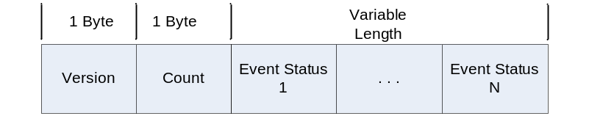
Figure 22 - Set Events Response Message Format
Field Name | Description
Version | Must be zero
Count | The number of Event Status objects.
Event Status 1 – N | Array of Event Status objects

Table 24 - Set Events Response Fields

Event Status
Indicates the status of an attempt to delete, add, or modify an event in the ZedPAC’s event database.

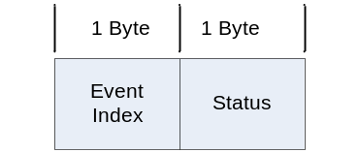
Figure 23 - Event Status Format
Field Name | Description
Event Index | The index number of an event
Status | The status of the attempt to modify this event.

Table 25 - Event Status Fields
Event Status Number | Description
0 | Success.
1 | Invalid Parameter value. Either event parameter 1, 2, or both are invalid.
2 | Too many events. No more events could be added because there are too many events defined on the ZedPAC.

Table 26 - Event Status Explanations

Add Extended IO Point
The Add IO Point message adds an IO Point to the ZedPAC’s IO point database.
Figure 24 - Add IO Point Format

Field Name | Description
Version | Must be zero
IO Point Index | Index number of the IO Point
Data Type | Data type of the IO point. See Table 14- Data Types
Pollset Number | Pollset number for this IO Point
IO Point Class | The class of the IO Point
RTU Address | Address of the RTU
F1 – F4 | Used to map the IO Point to an RTU register
Factor | Currently not used. Must be zero
Offset | Currently not used. Must be zero

Table 27 - Add Extended IO Point Fields
IO Point Class  Name | IO Point Class  Number | Description
System | 1 | Reserved for internal Diagnostic points. User defined points cannot use this reserved class.
RTU | 2 | Used for IO Point that come from external RTUs through the ZedPAC’s RTU driver
Internal | 3 | IO Points that are integrated into the device, for example Temperature.
Network | 4 | Used with specific Network Drivers that allow the use of pseudo IO Points to gather information from the driver
Table 28 - IO Point Class

Delete IO Point Message
The Delete IO Point message removes an IO Point from the ZedPAC’s IO point database.
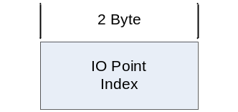
Figure 25- Delete IO Point Message Format

Demand Poll Message
The Demand Poll Message is used to request a poll of either an entire pollset or individual IO Point. If a pollset number is specified, the IO Point Index must be zero. If the IO point index is specified, the Pollset Number is ignored.
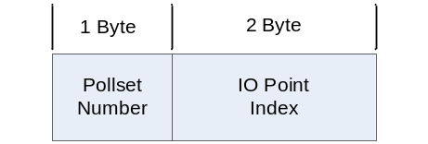
Figure 26 - Demand Poll Message Format

Write IO Point Message
The Write IO Point Message is used to set the value of an IO Point. The length of the data value depends on the data type. Refer to pervious sections for field definitions.
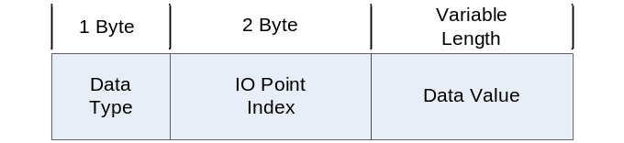
Figure 27 - Demand Poll Message Format

Request Time Message
The Request Time Message is used by the ZedPAC to request a time from the bridge and is used by the bridge to respond to a request for time.
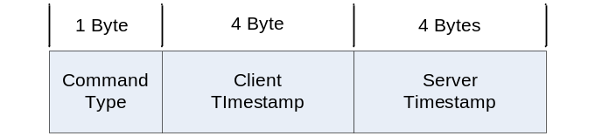
Figure 28 - Request Time Message Format

Field Name | Description
Command Type | Type of message:  0: Request (from ZedPAC)  1: Response (from bridge)
Client Timestamp | Filled in by the ZedPAC when the request is sent. Will be the same in the response. Number of seconds since Jan 1, 1970 UTC.
Server Timestamp | Filled in by the bridge when response is sent. Number of seconds since Jan 1, 1970 UTC.
Table 29- Request Time Message Format

IO Refresh
IO Refresh is a sequence of messages exchanged between the ZedPAC and the PAC Bridge to facilitate commissioning, or refreshing of IO Point information, of a ZedPAC. While it is possible to send all IO Points, alarms, system values, and events to a PAC as an individual messages, it is unlikely the PAC would be able to processes all messages and would likely lose messages in the process. The IO Refresh feature allows the PAC Bridge and ZedPAC to coordinate the sending and receiving of configuration information in an orderly fashion to ensure the ZedPAC processes all data correctly. The refresh is divided into phases, in which messages are batched together and sent to the ZedPAC. Once all messages have been processed by the ZedPAC, it must send a confirmation message before the next phase starts.

Figure 29 - IO Refresh States

IO Refresh Message
An IO Refresh message is used to send control messages for each of the states of an IO Refresh. The refresh message contains an array of GDN Messages that is specific to the phase being executed. For example, if an IO Refresh Message is sent during the “Add IO Point” phase, the refresh message will contain an array of “Add IO Point” messages. If an IO Refresh Message is sent during the “Set Events” phase, the refresh message will contain an array of “Set Events” messages. The size of the IO Refresh Message is limited so if one refresh message cannot contain all control messages for a single state, then more than one IO Refresh Message will be used.

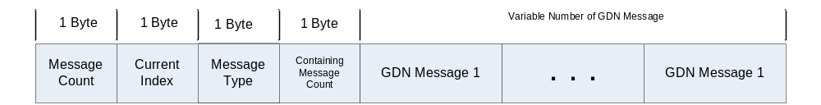
Figure 30 - IO Refresh Message Format

Field Name | Description
Message Count | The total number of IO Refresh Messages containing the same type of message indicated by the Message Type Field.
Current Index | The current number of IO Refresh Message
Message Type | The type of GDN Message contained in this message. This field should be set to the type of message being sent during the phase of the IO Refresh.
Containing Message Count | Number of GDN message contained in this refresh packet.

Table 30 - IO Refresh Message Fields
As an example, an IO Refresh operation requires 200 Add IO Point messages to be sent during the “Add IO Point” phase, but size limitations only allow 50 messages to be held in a single IO Refresh message. This means the 200 messages will be divided into four IO Refresh messages:
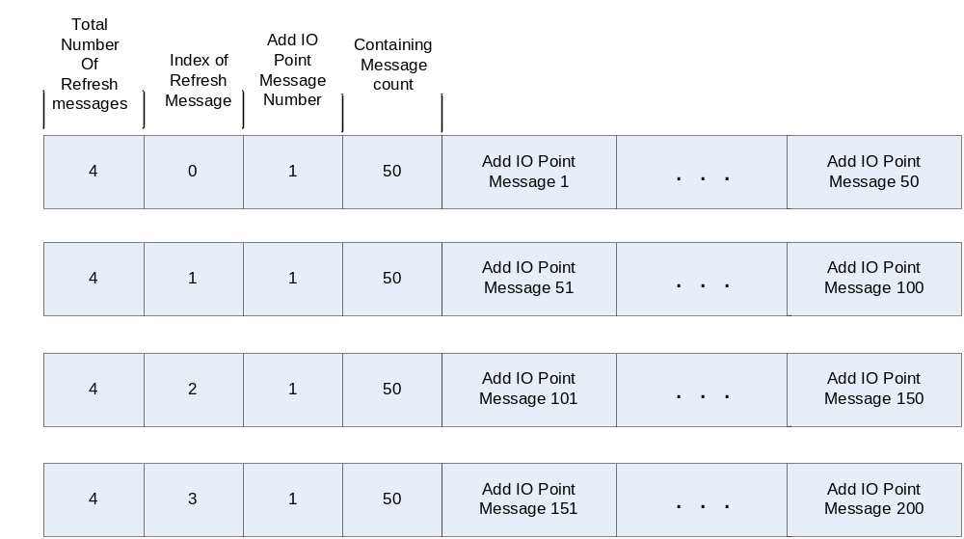
Figure 31 - IO Refresh Message Example
Note: If a certain phase has no data, for example: “Add Alarm Phase” has no alarms, the phase must still be processed, however the message count is set to 1, Current Index is set to 0, and the Number of GDN Messages is set to 0 signify no data. A response will be issued and the next phase will be entered.
Note: the “Set Events” message could contain multiple events within a single GDN message.

IO Refresh Response Message
Each phase of the IO Refresh requires the ZedPAC to send a response back to the PAC Bridge before the next phase is entered. The response message contains the following format:
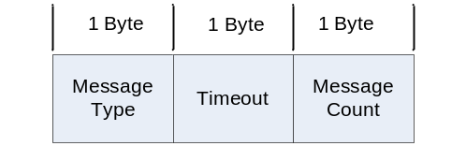
Figure 32 - IO Refresh Response Message Format

Field Name | Description
Message Type | This field matches the message type of the IO Refresh Message. i.e. it indicates the type of messages that were last processed.
Timeout | This field is an error indicator. If the field is set to 1, then the IO Refresh operation on the ZedPAC timed out waiting for all messages for a single phase.
Message Count | Indicates the number of IO Refresh Messages that were processed. If this field does not match the Message Count field of the IO Refresh Message, then the operation failed.

Table 31 - IO Refresh Response Message Fields

Set Events Message
The Set Events Message is the same as the Set Events Message described in the Set Events Message section. The expected response message is the same as described in the Set Events Response Message section.

IO Refresh example
In the following example, an IO Refresh operation is performed that requires the number of Add IO Points messages to be send in two IO Refresh Messages. The Configure Alarms message can be sent in a single IO Refresh Message. The Set Events Message can be sent in a single IO refresh message. The Write IO Point message required two IO Refresh Messages, sent at the end.
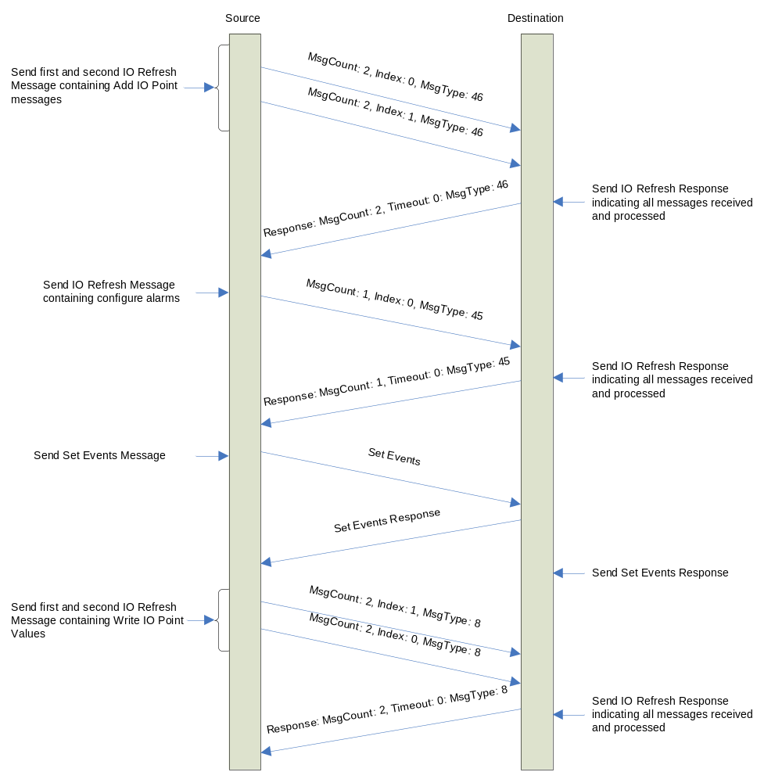
Figure 33 - IO Refresh Message Example

PAC Console Messages
PAC Console Messages allow remote interaction with the ZedPAC’s ASCII console. A PAC Console session is initiated by a sending any PAC Console Command message to the ZedPAC. Once the session is established, the ZedPAC responds to PAC Console Command messages with PAC Console Display messages. To close the console session, the PAC Bridge sends a PAC Console Close command.
With the exception of the Close Command, the first byte of all PAC Console Command messages is an index number that is incremented each time a message is sent. The PAC Bridge maintains the index numbers of the Command Message and the ZedPAC maintains the index of Display Messages. The index numbers can be used to sequence commands or responses.

PAC Console Close Command
The PAC Console Close Command message closes a PAC Console session. It contains two bytes: the first byte must contain 253 and the second byte zero.
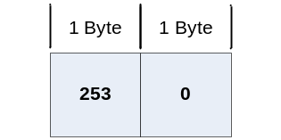
Figure 34 - PAC Console Close Command Message Fields

PAC Console Command Message
The PAC Console Command Message is used to send console commands to the ZedPAC. The console command is an ASCII string encoded as 8 bit byte array.
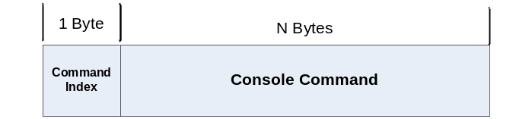
Figure 35 - PAC Console Command Message Format

PAC Console Display Message
The PAC Console Display Message contains the output from a console command sent to the ZedPAC. It is only sent from the ZedPAC to the PAC Bridge. The console output is an ASCII string encoded as 8 bit byte array.

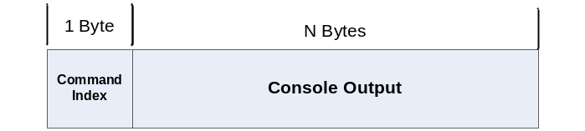
Figure 36 - Figure 38 - PAC Console Display Message Format

